Name: ________________________

HUMAN BIOLOGICAL SCIENCES ATAR Key Unit 4
Test 5: Evidence of Evolution

Section 1: Multiple Choice (1 mark each)
1. C | 6. C
2. C | 7. B
3. C | 8. D
4. C | 9. A
5.B | 10. A

Section 2: Short Answer
1. Besides the study of fossils, much of the evidence for evolution has come from comparative studies. The diagrams below show an example of one of these methods. They show the appearance of several vertebrate pentadactyl limbs.

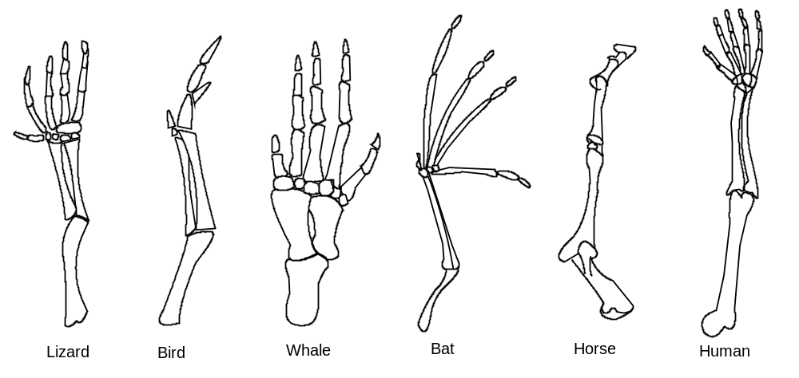

a) Name and describe the specific type of comparative study being illustrated in these diagrams. (2 marks)
Homologous Organs (1)
Organs (Forelimbs) with a similar structure but not all with a similar function (1)
b) Explain how this method can provide support for the theory of evolution. (1 mark)
Organisms with a similar structure are likely to have a common ancestor (1)
c) More recent methods have involved biochemical studies which examine similarities and differences at the molecular level. Included in these are studies of DNA and protein in different species.
Explain how the study of proteins can provide evidence for evolution. (2 marks)
By comparing Amino acid sequences in similar proteins of different species, the degree of similarity can be determined. (1)
The longer the separation of species the greater the difference in Amino acid sequence. (1)

2. The following Diagram shows 3 rock samples taken from 3 different sites. Each of the layers of rock contains a fossil
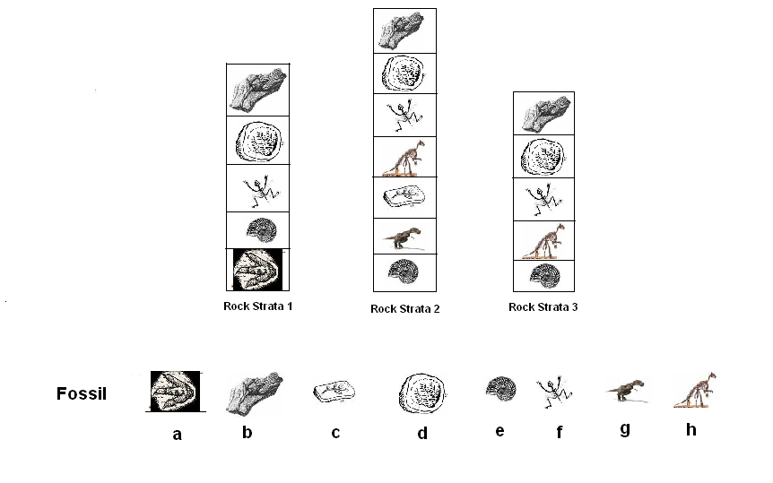

a) What is the name given to this method of studying rock layers in archaeology?
Stratigraphy (1) (1 mark)

b) Which of the dig sites 1, 2 or 3 Contains the oldest layer? (1 mark)
Site 1 (1)
c) How do you know it is the oldest? (1 mark)
index fossil (e) in all three sites, Site 2 and 3 it is at the base 1 has a fossil below. (1)
d) What is name given to such a group of fossils that is found in different parts of the world and indicates a specific time period? (1 mark)
index fossil (1)
e) Use the information to place the fossils in order from oldest to youngest. (1 mark)

Oldest A E G C H F D B Youngest (1)

3. a) If a skull was found in sedimentary deposits, and some tools were also found, explain how fluorine dating could be used to decide whether the skull and the bone tools were of the same age. (2 marks)
Fluoride ions replace some of ions in the fossil (1)
Fluoride ions are the same (1), older the fossil the more fluorine ions (1) 2 marks max
b) Explain if the dating method mentioned in 13a is absolute or relative and what they each mean. (2 marks)
Relative Dating (1)
Relative dating – not possible to determine the actual age of a fossil.
Absolute dating – gives the actual age of the fossil (1)
c) If a skull was dated at 50 000 and another was 200 000 which skull could have been dated using radiocarbon dating (carbon 14) dating method? Explain your answer fully.
(3 marks)
50 000 (1)
Half life of 5730 years quantity of carbon is negligible at 70 000 years (1)
Carbon dating only useful up 60 000 years (1)
d) Explain how a fossil could be formed. (3 marks)
Conditions need to be correct (1)
Minerals replace organic matter (1)
Bone becomes petrified (turned to rock) (1)
4. Carbon 14 dating techniques are commonly used methods for fossil dating. Given that the half life of C¹⁴ is 5730 years.
a) Graph the decay curve. Carefully label the axes and indicate the values on each axis. (5 marks)
Title (1)
Percent on Vertical, Years on Horizontal (1)
Scale (1)
Line graph (1)
Correct plot (1)
b) Making specific references to your graph, explain what a half life is and the importance of isotope decay rates to the most accurate dating of fossil materials.
(4 marks)
A half life is the time taken for the amount of radiation in the sample to halve. (1)
It is accurately known for different element and does not change due to environment. (1)
The fossil is best dated when the slope of the graph is the steepest (1)
This area is easier to measure because there is a small difference for a large radiation difference. (1)
Must contain carbon (1)
Max 4 marks
c) Potassium⁴⁰ (K⁴⁰) is another radio-isotope used in dating fossil objects. Given that the half life of K⁴⁰ is 1.25 x 10⁹ (1 250 000 000) years and what you know about this dating method, explain the circumstances under which you would use K⁴⁰ rather than C¹⁴ to estimate the age of a fossil. (4 marks)
Potassium ⁴⁰ is used to date older fossils because it has a much longer half-life than Carbon ¹⁴ (2)
It can be used to date materials that do not contain carbon. (2)

5. The rows of diagrams below show the appearance of a number of vertebrate embryos and the adult form. Use this information to provide detailed answers to the following questions.
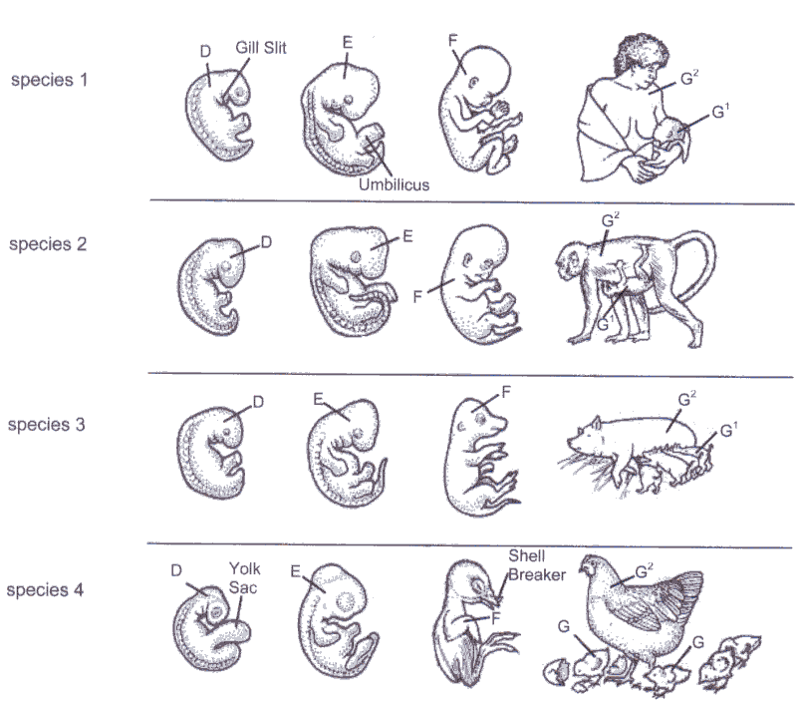

- What process is illustrated in each row of diagrams? (1 mark)
Development or Growth and Differentiation (1) or
Embryology (1)
- When comparing this process among the four species above, what two generalisations are clear? (2 marks)
Early stage similar development (1) compared to later stage (1)
Or all start with gill slits (1) then develop head, limbs and then postnatal tail (1)
- Explain how these generalisations may be used to support the theory of evolution. (2 marks)
Similar in early development indicates common ancestor (2)

6. Comparative studies of DNA have provided further evidence of evolution.
    - Discuss how ERVs are helping scientists track DNA back through our common ancestors. (3 marks)
Endogenous Retroviruses (1)
On the same spot on a chromosome able to match (1)
If they have same ERV come from same ancestor (1)
    - What is mtDNA? Explain why it is a useful tool in providing evidence for evolution. (4 marks)
mItochondrial DNA (1)
Only passed from your mother (1)
mtDNA mutations are proportional with time. (1)
The greater the difference in mtDNA long ago a common ancestor (1)

END OF TEST
TOTAL: 55 MARKS

